Rest Documentation: https://github.com/rest-assured/rest-assured/wiki/Usage
Link: https://www.youtube.com/watch?v=LSR8g_Wgw94&t=407s

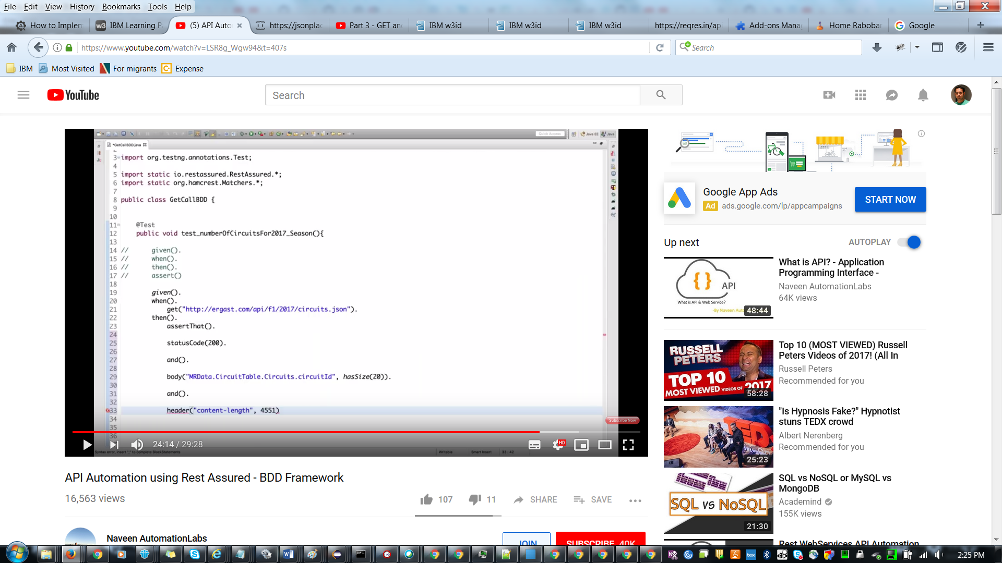

Rest API Post Example :
Link : https://www.youtube.com/watch?v=vjxy3KkYihQ&list=PLEiBaBxmVLi-hoi61aX-2agQb8EXSCT5f&index=2

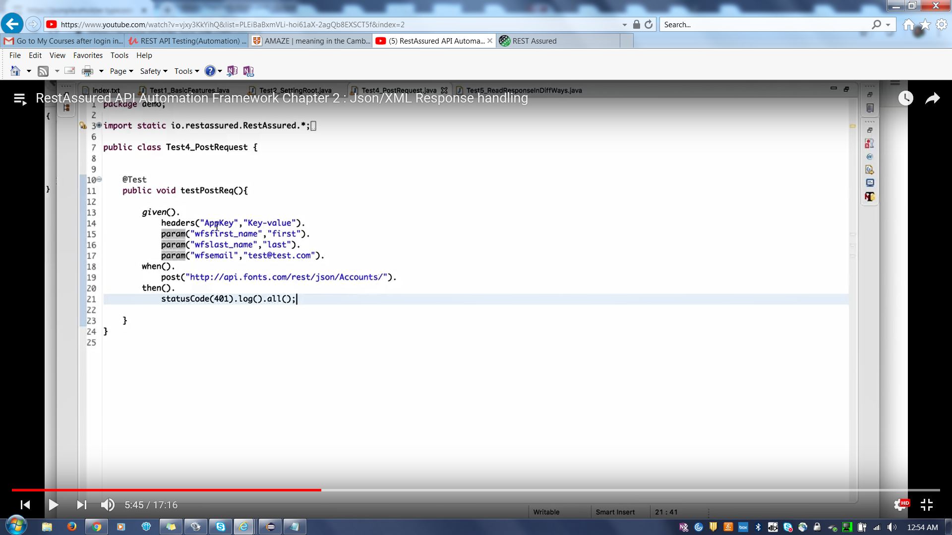

Link for Post : https://www.youtube.com/watch?v=BPMON4Fb4NA

Response response = given().contentType(“application/json”).accept (“application/json”).body().when().post(“Link”)Statuscode(200).contentType(“application/json”).extract().response();

String userId = Response.jsonpath().getString(“userId”);

assertNotNull(userID”);
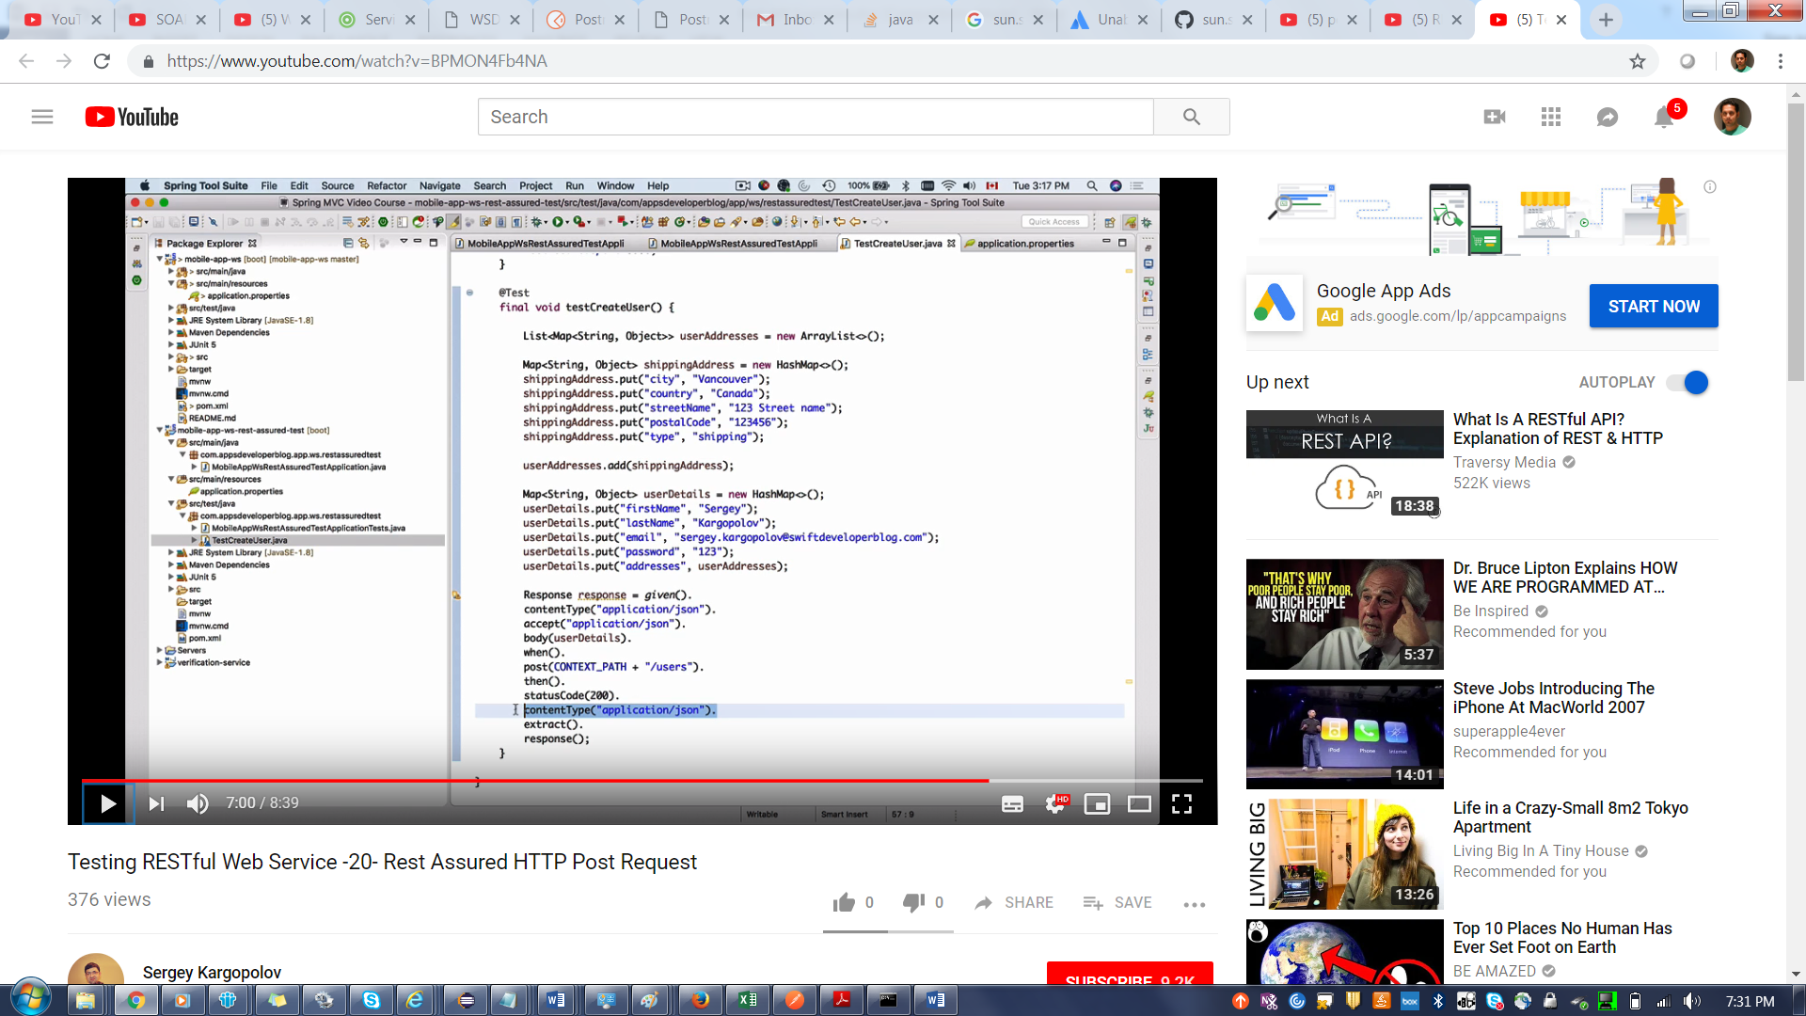

public class AccountTest
{
final Header header1 = new Header("Content-Type", "application/json");
final Header header2 = new Header("mule_client_id", "xxxxxxxxx");
final Header header3 = new Header("mule_client_secret", "xxxxxxxx");
final Header header4 = new Header("Authorization", "Bearer xxxxxxxx");
Headers headers = new Headers(header1, header2, header3, header4);
@Test
public void createaccounttest()
{
File file = new File("/Users/kbay/IdeaProjects/RESTproj/CreateAccount.json");
String content = null;
Response resss = given().when().headers(headers).contentType(ContentType.JSON).body(file).post("https://api-int.petco.com:444/accessmanagement-cfa-exp-api/v1/accounts");
System.out.println(resss.getStatusCode());
}
}

RestAssured.baseURI = http://localhost:8000;
RestAssured.basePath = “student”
Given().

